Deerwalk Institute of Technology
Sifal, Kathmandu

Simulation and Modelling Practical

Submitted By: Submitted To:
Name: Sagar Giri Binod Sitaula
Roll No: 205
Section: A

Date:

Background Theory

Linear Congruential Method to generate random numbers.

It is the most commonly used technique for generating ransom numbers and was initially purposed by Lehmer in 1951. This technique provides a sequence of integer between 0 and 1 by following recursive relation:
for i=0,1,2,.....
where Xo = Seed
a = multiplier
c = increment
m = modulus
If , then the method is called mixed congruential method, else it is called multiplicative congruential method.

Program Coding:

#include <stdio.h>
#define MAX 50
int main()
{
int a,m,c,i,x,j,flag=0,N=0, choice;
float rand[MAX];
printf("Mixed (1) or Multiplicative (2)?\n");
scanf("%d",&choice);
if(choice == 1)
{
printf("Enter the value of c");
scanf("%d",&c);
}
printf("Enter the value of x0, a & m\n");
scanf("%d%d%d",&x,&a,&m);
while(1) {
rand[i] = (float)x/m;

for(j=0;j<=i;j++) {
if(i==j) {
continue;
}
else if(rand[i] == rand[j]) {
flag = 1;
break;
}
else{
flag = 0;
}
}
x = (a*x+c)%m;
printf("%f\n",rand[i]);
N++; i++;
if(flag ==1){
break;
}
}
printf("\nno of randoms= %d",N);
return 0;
}

Program Output:
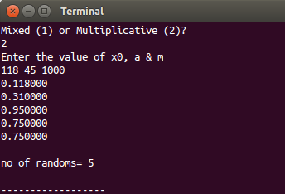

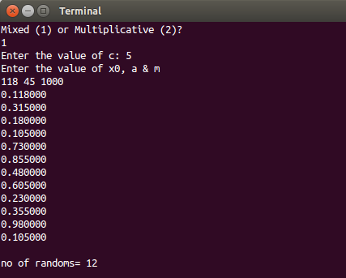

Conclusion:
Hence the Linear Congruential method was applied to generate a series of random numbers in C-Programming language.

